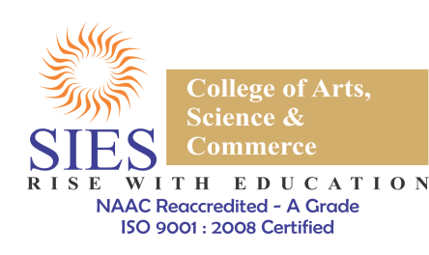

Name of the event: Pose for a Cause
Date: 20-22nd September, 2018
Start Time: Day 1 - 07:00 p.m.
End Time: Day 3 - 7:00 p.m.
Aim:
The aim of conducting this event was to use social media to talk about how our freedom of speech is still stifled and show a mirror to the society by using “#chargeme” i.e. charge me for anything that I’m doing which I am not supposed to do according to the society.
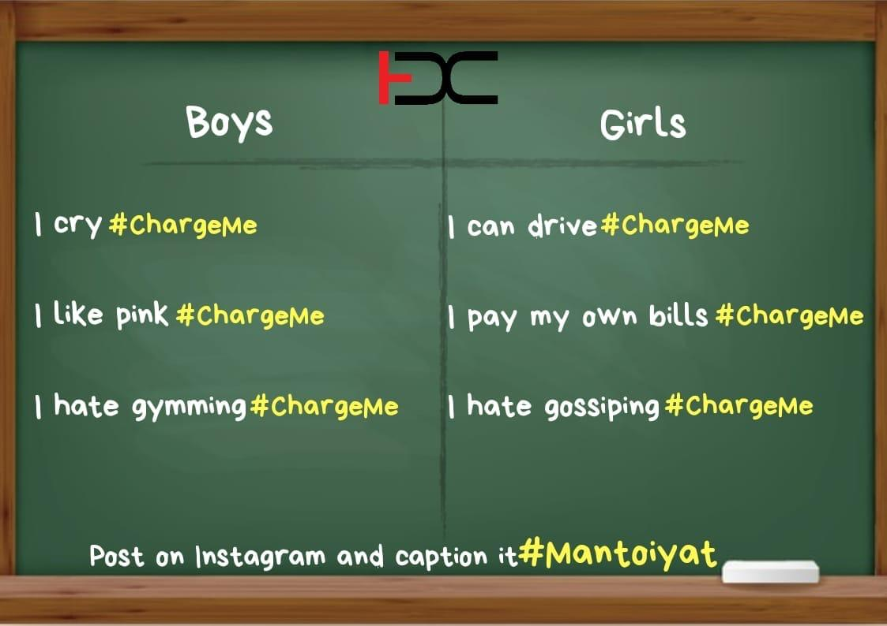
About the event:
The event was in association with ‘Viacom 18’ wherein students from all departments of our college voluntarily stood up for this cause. Not only the students, but also our faculty actively encouraged everyone to break the stereotypes. There were more than 130 students who came forward to enhance the event by their support. The students were supposed to hold up placards about what they should be charged about and post it across their social media accounts with the hashtag “CHARGEME” and by tagging our official EDC Instagram ID.
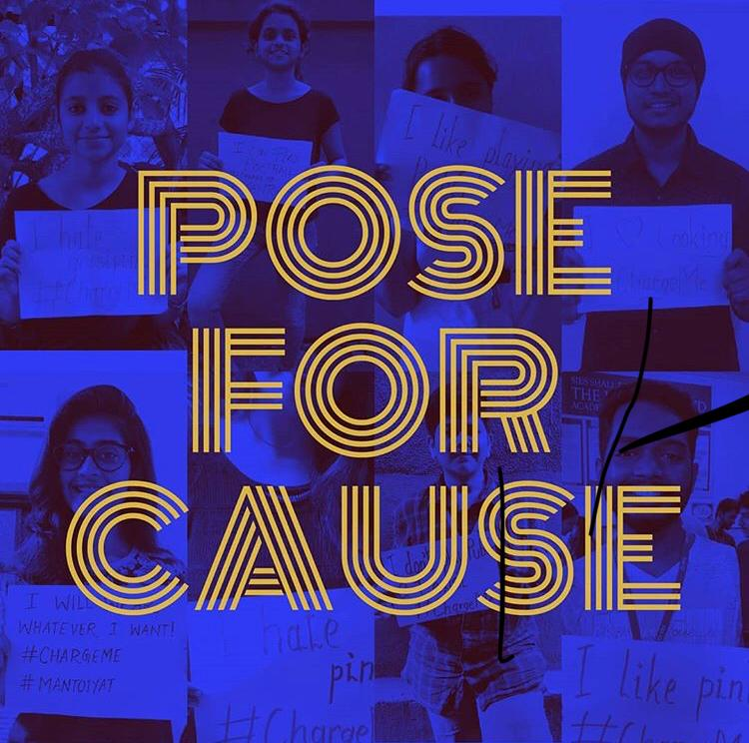
Summary:
The after-effect of this event was great, we got an engagement of more than 2000 people visiting our profile and knowing about EDC. It was very helpful for EDC in reaching out to the students of our college who yet didn’t know about our cell.

